(English Version)

Visual Path
Your Gate Way to Free
Knowledge.
INTRODUCTION:
Welcome to Visual Path, the ultimate solution for high
school students (Grade 9 Up To 12) who need quick and
easy access to textbooks online. We understand the
struggle of finding the right learning materials, so we
created a platform that simplifies the process. Our goal is
to make education more accessible by providing a
seamless way to search, find, and download textbooks
instantly.

About Us:
Visual Path was founded by two students, Azaryas Chombe
and Abel Mulate, who recognized the challenges students face
when looking for textbooks online. We wanted to create a platform that removes the hassle of searching multiple websites and instead provides a one-stop solution. Our mission is to help
students succeed by ensuring they have the learning resources
they need at their fingertips.
We are Grade 9 students from Betelhem Secondary School,
both 15 years old. We built this website using HTML CSS and Java Script, and it
took us over 30 days to complete. As future software
engineers, we are passionate about technology and innovation.
Our dream is to help our country advance in the field of technology as we grow older, making it more modern and
efficient. We are committed to using our skills to contribute to a
better, tech-driven future for our nation.
And we Understand That This Website is not that much professional but we believe we can make it better its all about Time.
Why You Need To Choose Visual Path?
•
Fast and Easy Access – No more searching endlessly; find
your textbook in seconds.
•
User-Friendly Interface – Simple and intuitive design for a
smooth experience.
•
Free to Use – No hidden fees or subscriptions; just direct
access to learning materials.
HOW IT WORKS:
1.Search for Your Textbook – Enter the name, subject, or
author to find your book.

2.Select Your Book – Browse through the available options
and pick the right one.
3.Download Instantly – Get the textbook in a downloadable
format within seconds.

OUR VISION:
We believe that education should be accessible to
everyone, regardless of financial or geographical
limitations. By streamlining textbook access, we aim to
support students in their learning journey and help them achieve academic success without unnecessary
obstacles.
OUR WEBSITE LOGO:

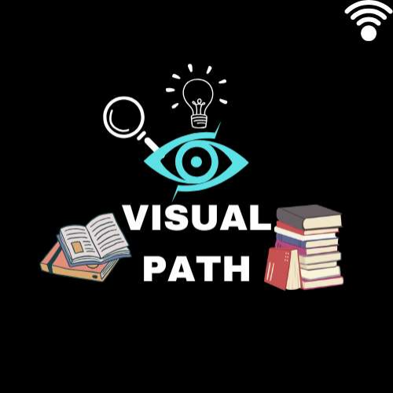

While making our website: (screenshot)

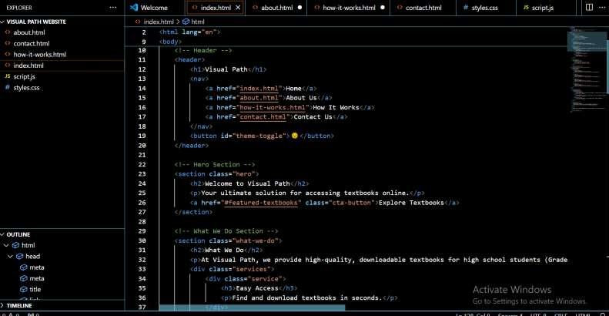
Tools Used to make this website:

Visual Studio (For the programming Of Our Website)
Canva (To make the logo of our website)
ChatGpt (To fix our mistakes) WHILE MAKING OUR WEBSITE
Contact Us:
If you have any questions, feedback, or suggestions,
feel free to reach out to us. We’re always looking
to improve and expand our platform to better serve
students like you And Like Us!
Email: [LilAzar11s@gmail.com
Or
[Tubem852@gmail.com]phone: [+251911121200] or [+251973839704]
ALWAYS SEEK TO GAIN NEW
KNOWLEDGE.
WANTS TO ASSIST OUR COUNTY.
Future software Enginners…….

(በ አማርኛ)
Visual Path
ነፃ ዕውቀትን ለማግኘት

መግቢያ
ወደ VISUAL PATH WEBSITE እንኳን በደህና
መጡ
የሁለተኛ ደረጃ ተማሪዎች የመጨረሻው መፍትሄ ፈጣን
እና በቀላሉ መማሪያ መጽሀፍቶች የሚያስገኝ
Website. ትክክለኛውን የመማር
ቁሳቁሶችን ለማግኘት የሚደረገውን ትግል እንረዳለን,
ስለዚህ ሂደቱን ቀለል የሚያደርግበት መድረክን ፈጠርን.
ግባችን የመማሪያ መጽሀፍቶች ኦንላይን
በማቅረብ ትምህርት የበለጠ ተደራሽ
ማድረግ ነው.
ስለእኛ፡
Visual Path በሁለት ተማሪዎች የተቋቋመ ሲሆን ተፈታታኝ
ሁኔታዎችን ባወቁት አዛርያ እና አቤል በ
ሚባሉ ሁለት ተማሪዎች ነው. በርካታ websiteኦችን መፈለግን የሚያስወግድ መድረክ ለመፍጠር ፈለግን.
ተልእኳችን ተማሪዎች የሚፈልጉትን የመማሪያ ሀብቶች
እንዳላቸው በማረጋገጥ እንዲሳካላቸው መርዳት ነው.
HTML በመጠቀም ይህን web ገንብተናል , እናም
ለማጠናቀቅ ከ 30 ቀናት በላይ ፈጅቶናል. የወደፊቱ
የሶፍትዌር ኢንጅነር እንደመሆናችን መጠን ስለ
ቴክኖሎጂ እና ፈጠራ ፍቅር አለን. የእኛ ህልም እያደግን
ስንሄድ የበለጠ ዘመናዊ እና ቀልጣፋ በማድረግ
በቴክኖሎጂ መስክ ውስጥ ሀገራችንን መርዳት ነው.
ወደፊቱ ለህዝባችን ለተሻለ አስተዋጽኦ ለማበርከት ችሎታችንን ለመጠቀም ቆርጠናል.
የእይታ መንገድ ለምን ይምረጡ?
ቀላል ተደራሽነት - ከእንግዲህ ማለቂያ የሌለው ፍለጋ
አይፈልጉም; የመማሪያ መጽሐፍዎን በሰከንዶች ውስጥ
ይፈልጉ.
ቀላል እና በቀላሉ ሊታወቅ የሚችል ንድፍ.

ሎጎአችን፡

Website ኡን ለመስራት የተጠቀምንባቸው
ቱሎች፡

Visual Studio (websiteኡን ፕሮግራም ለማድረግ)
Canva (ሎጎውን ለመስራት)
ChatGpt (ስህተቶቻችንን ለማረም)
ያግኙን: ማንኛውም ጥያቄ, ወይም አስተያየቶች
ካሉዎት እኛን ለማማከር ነፃነት ይሰማዎ. እኛ
እንደ እርስዎ እና እንደ እኛ ያሉ ያሉ
ተማሪዎችን በተሻለ ለማገልገል ሁል ጊዜ እንፈልጋለን!
ኢሜል: [lialazar11s@gmail.com
ወይም
[Tubem852@gmail.com]
ስልክ: 0911121200 ወይም 0973839704
ሁልጊዜ አዲስ እውቀትን ለማግኘት ይፈልጉ.
የወደፊቱ የሶፍትዌር ኢንጂነሪንግ ተስፋዎች .......

